
Halifax Sustainable Event Program
Social media post templates
Feel free to edit these social media posts to suit your brand voice and positioning. They’re meant to add as a starting place. See the Asset Kit for LinkedIn, Facebook, and Instagram graphics to accompany your social media post(s).
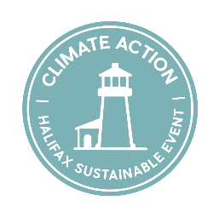
Climate Action Badge
Option 1: Short
We are proud to be recognized by the Halifax Sustainable Events Program for our commitment to reducing the environmental impact of [Event Name].
Because the best events don't just happen in a place, they help preserve it.
#Meetingwithpurpose #SustainableEvents #BusinessEvents #Climate Action
Option 2: Long
We're proud that [Event Name] has been recognized with the Climate Action Badge as part of the Halifax Sustainable Events Program.
Every conference leaves a footprint. We're working to ensure ours is a lighter one by making thoughtful choices that reduce environmental impact while creating a better experience for attendees.
Some of the initiatives we're proud to be implementing include:
• [Initiative]
• [Initiative]
• [Initiative]
Because creating a great event also means helping protect the places that make it memorable.
#Meetingwithpurpose #SustainableEvents #BusinessEvents #Climate Action
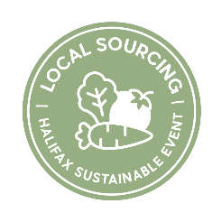
Local Sourcing Badge
Option 1: Short
We're proud to share that [Event Name & year] has been recognized for it’s Local Sourcing initiatives through the Halifax Sustainable Events Program.
By choosing local businesses, products and experiences whenever possible, our event won’t just happen in Halifax, it will help support its growth.
#Meetingwithpurpose #SustainableEvents #BusinessEvents #LocalSourcing #BuyLocalNS
Option 2: Long
We're proud that [Event Name] has received a Local Sourcing recognition as part of the Halifax Sustainable Events Program, for our commitment to working with local producers and suppliers, while hosting in Halifax.
Every event has the opportunity to create meaningful impact. We're proud to be taking steps that help strengthen our host community and enrich the attendee experience.
Here's how we're working toward that goal:
• [Initiative]
• [Initiative]
• [Initiative]
Because the best events don't just happen in a place, they help support it.
#Meetingwithpurpose #SustainableEvents #BusinessEvents #LocalSourcing #BuyLocalNS

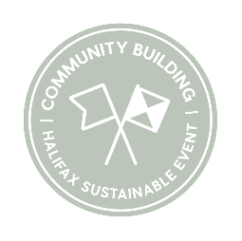
Community Building Badge
Option 1: Short
We are thrilled to receive the Community Building recognition as part of the Halifax Sustainable Events Program, for building community impact and engagement into the format for [Event Name & Year].
Because the best events don't just happen in a place, they help strengthen it.
#Meetingwithpurpose #SustainableEvents #BusinessEvents #CommunityEngagement
Option 2: Long
We're proud that [Event Name] has received a Community Building recognition as part of the Halifax Sustainable Events Program.
Every event has the opportunity to create meaningful impact. We're proud to be taking steps that help strengthen our host community and enrich the attendee experience.
Here's how we're working toward that goal:
• [Initiative]
• [Initiative]
• [Initiative]
Because the best events don't just happen in a place, they help strengthen it.
#Meetingwithpurpose #SustainableEvents #BusinessEvents #CommunityEngagement

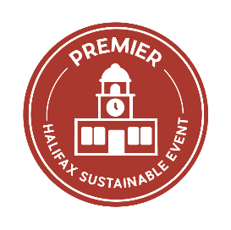
Premier Sustainable Event Badge
Option 1: Short
We're honoured that [Event Name] has been recognized as a Premier Sustainable Event through the Halifax Sustainable Events Program, celebrating our commitment to Climate Action, Local Sourcing and Community Building.
Because the best events don't just happen in a place—they help shape it.
#Meetingwithpurpose #SustainableEvents #BusinessEvents #CommunityImpact
Option 2: Long
We're honoured that [Event Name] has been recognized as a Premier Sustainable Event by Halifax’s Sustainable Event Program.
This recognition reflects meaningful progress across three pillars:
🌿 Climate Action
🏡 Local Sourcing
🤝 Community Building
Throughout our planning, we've worked to create an event that not only delivers an exceptional experience for attendees, but also contributes to a stronger community, a healthier environment and a more resilient local economy.
Some of the initiatives we're proud to deliver include:
• [Initiative]
• [Initiative]
• [Initiative]
We're grateful to our attendees, partners and sponsors for helping make that possible.
#Meetingwithpurpose #SustainableEvents #BusinessEvents #CommunityImpact

